**Excel Assignment 4**

1. What is the benefit of Microsoft 365?

Over 150% ROI. ...

Have all the tools your business needs to work more efficiently. ...

Access your office anywhere, anytime. ...

Easily scalable. ...

Cross-collaboration has never been easier. ...

Stay updated. ...

always be secure in Office 365. ...

Have the flexibility to mix and match.

1. Use two datasets and perform join on specific columns.

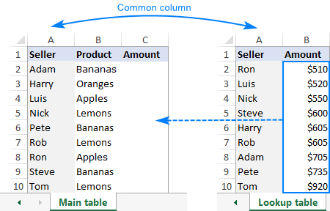

=VLOOKUP($A2,'Lookup table'!$A$2:$B$10,2,FALSE)

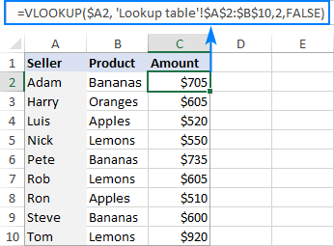

1. How to perform string formatting in excel. Demonstrate it with examples.

The syntax for the TEXT function is =TEXT(value,format_text). The format for the percentage I want is "0%". The format for the dollar amount is "$#,$$0.00". Note that both need to be in double quotes

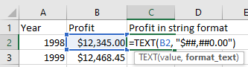

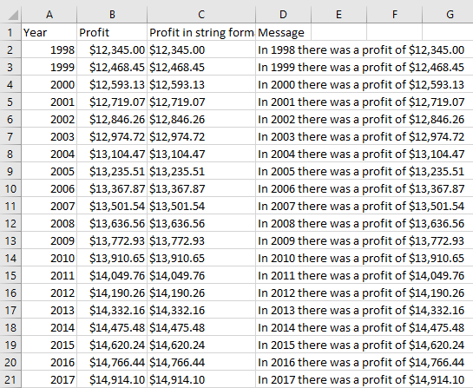

1. Create an advance expense distributor in excel.

Example: Consider expenses of a person who will be entered in excel at the same time expenses must be evenly distributed among all people with the amount of money each person should return/ receive.

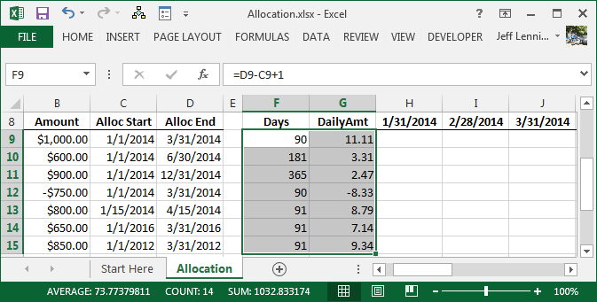

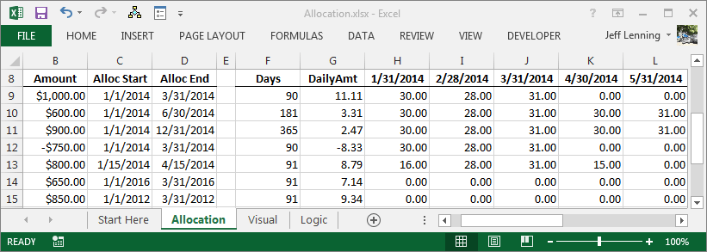

1. Create reports to generate mark sheets of students in excel where percentages and addition of marks should be done using formulas.

